Single crown
单冠
- Double click “UP3DCAM” to open it.(双击CAM图标，打开软件）
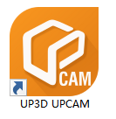
- Click the “New order” icon in the upper left corner to create a new order.（点击左上角的“新建订单”）
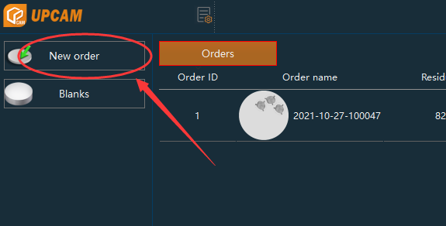
- After selecting the Milling machine and material and click “Next”.（选择加工机和材料后点击“下一步”）
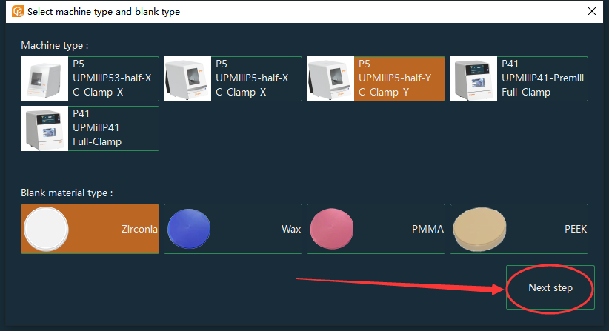
- Import the data to be nested, click "Next" after the import is complete（导入要排版的数据，导入完成后点击“下一步”）
  - After opening the data folder on the left, the data will be automatically parsed to the middle directory（打开左侧的data文件夹后，数据将被自动解析到中间目录）
  - Click "+" to import the data to be nested（点击“+”导入需要排版的数据）
  - Select the corresponding restoration type（we can follow this picture）（选择相对应的修复体类型（我们可以参照下面的图片））
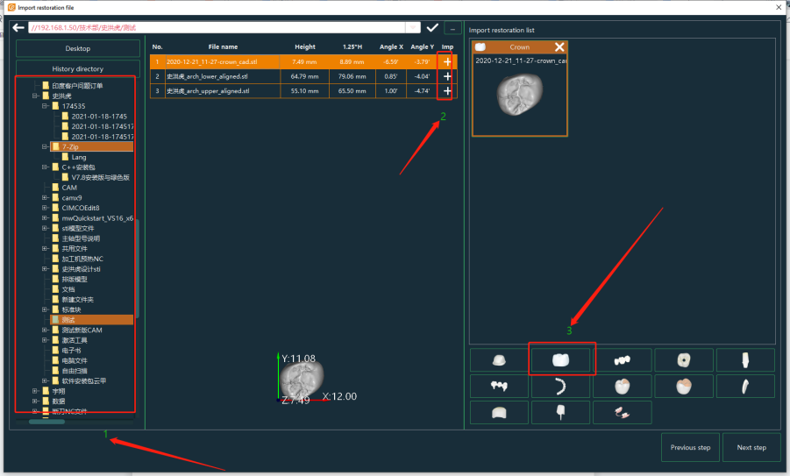
- Select the appropriate zirconium block, click "Next" after selecting（选择合适的锆块后点击“下一步”）
  - Click "+" to create a new zirconium block（点击“+”创建一个新的锆盘）
  - Click on the historical order to select the used zirconium block（点击历史订单，选择使用过的锆盘）
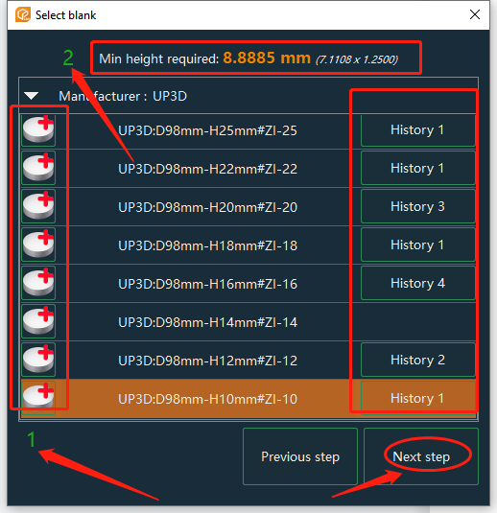
- Draw margin line：we can use one point detection or lesso detection.（画边缘线:我们可以用一点识别或套索识别）
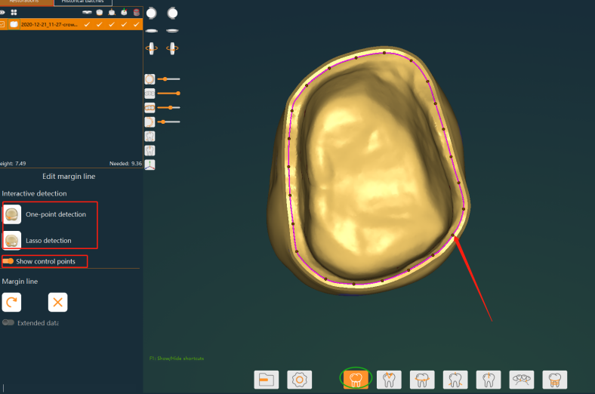
- Check the insertion direction: drag the small arrow to adjust the angle, and the angle of the AB axis in the insertion direction cannot exceed 20 degree, also can use optimized insertion direction to adjust it. （检查插入方向:拖动小箭头调整角度，AB轴在插入方向上的角度不能超过20度，也可以使用优化插入方向进行调整）
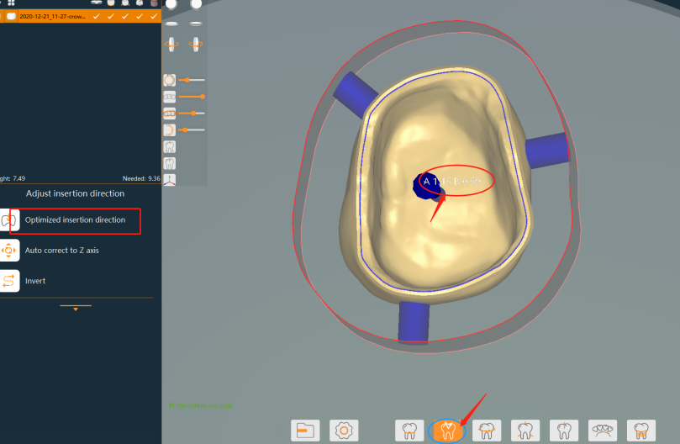
- Adjust the position of the teeth: be sure to start from the opposite side of the clamp (the angle will change after the teeth are rotated, pay attention to the 20-degree limited)（调整牙齿位置:一定要从夹具的另一侧开始(牙齿旋转后角度会变化，注意限制20度)）
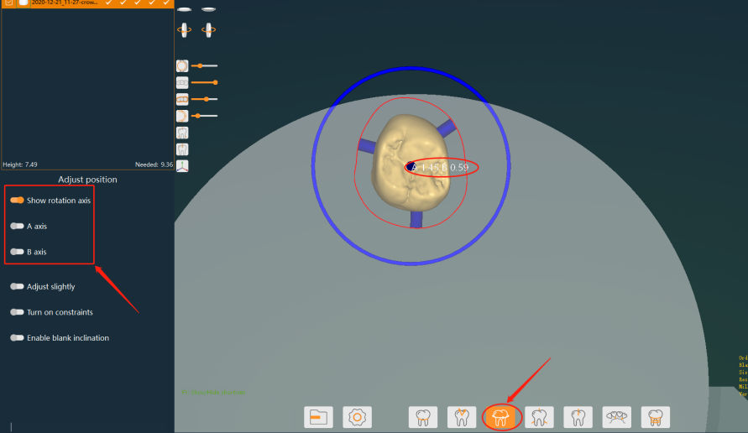
- Edit the connecting rod: try to place the connecting rod on the white line (higher point of the shape), and the number of connecting rods is not less than: the number of teeth + 2（编辑连杆:尽量将连杆放置在白线上(外形高点)，连杆数量不小于:牙齿数量+ 2）
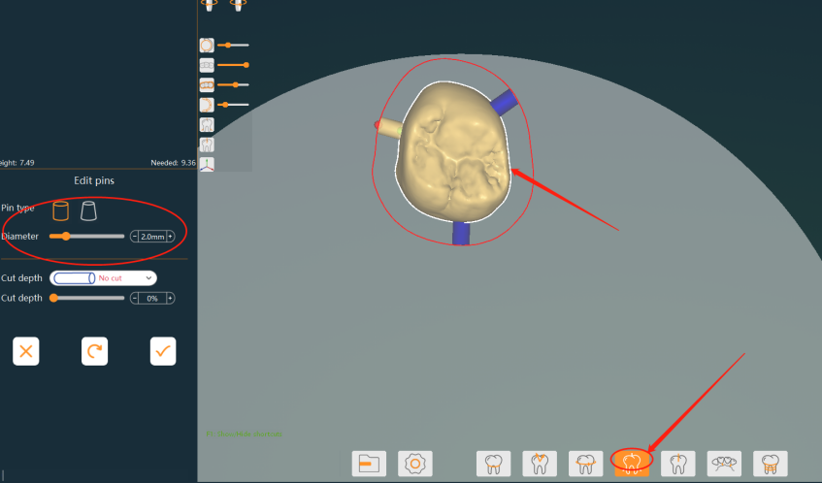
- Finally：Generate toolpath.（最后：计算刀路）
