Implant crown

- Double click “UP3D CAM” icon and open the software.
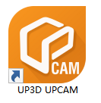
- Click the “New order” icon in the upper left corner to create a new order.
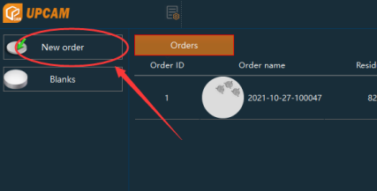
- After selecting the Milling machine and material and click “Next”.
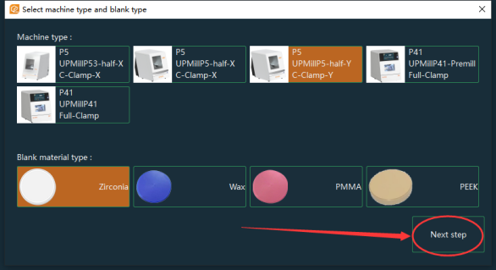
  - After opening the data folder on the left, the data will be automatically parsed to the middle directory
  - Click "+" to import the data to be nested.
  - Select the corresponding restoration type（we can follow this picture）.
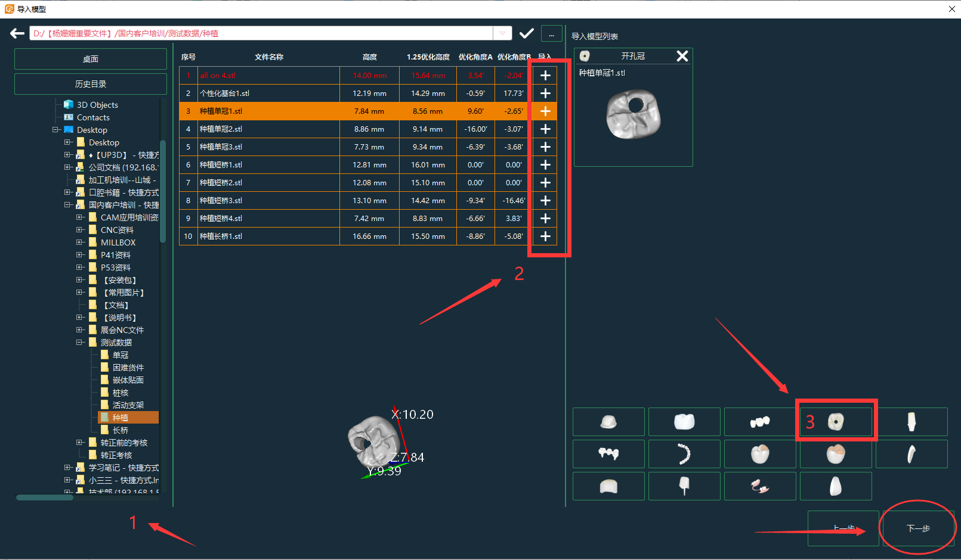
- Select the appropriate zirconium block, click "Next" after selecting.
  - Click "+" to create a new zirconium block.
  - Click on the historical order to select the used zirconium block.
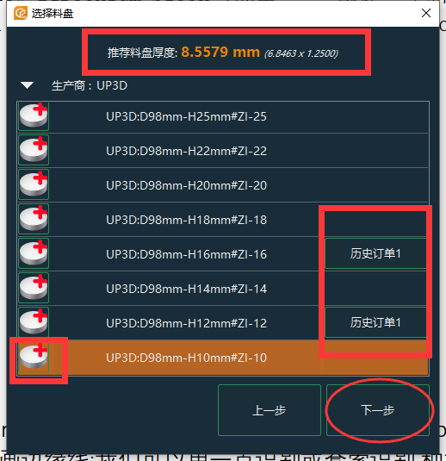
- Draw margin line：we can use one point detection or lesso detection.The implant crowns must have three edge lines.:Red,yellow and green.
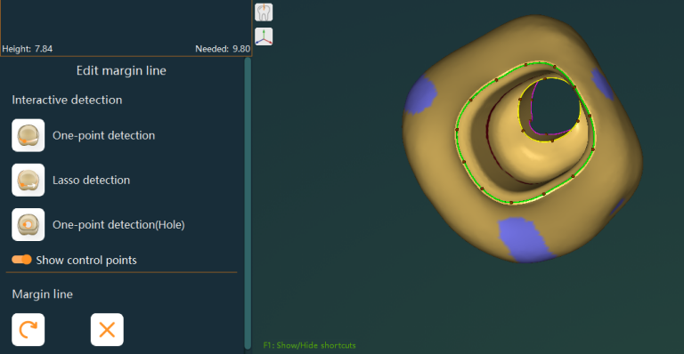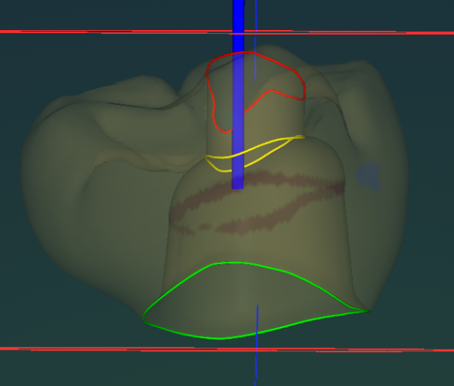
- Check the insertion direction: drag the small arrow to adjust the angle, and the angle of the AB axis in the insertion direction cannot exceed 20 degree, also can use optimized insertion direction to adjust it.
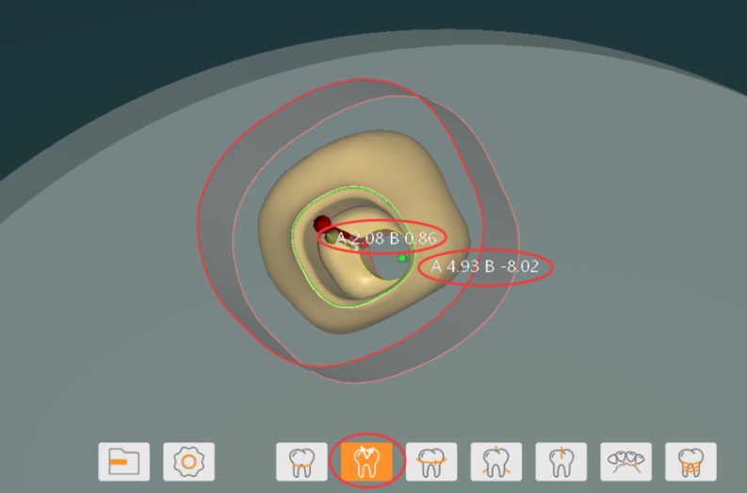
- Adjust the position of the teeth: be sure to start from the opposite side of the clamp (the angle will change after the teeth are rotated, pay attention to the 20-degree limited).
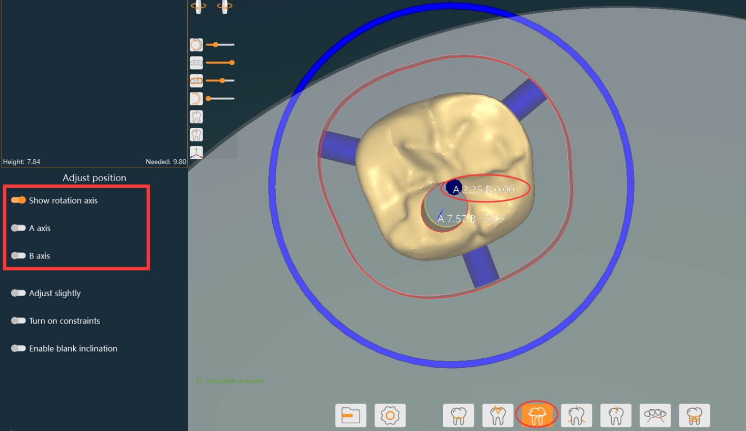
- Edit the connecting rod: try to place the connecting rod on the white line (higher point of the shape), and the number of connecting rods is not less than: the number of teeth + 2.
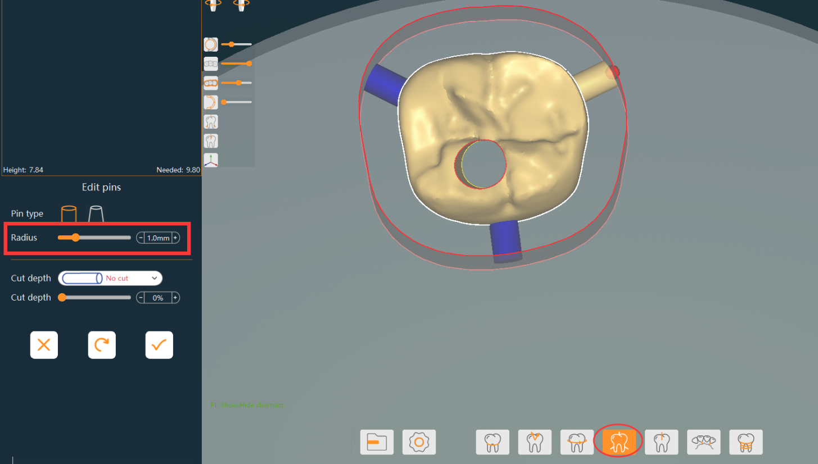
- Finally：Generate toolpath.
